1. Python main.py (click Enter)



1. Click Rock、Paper or Scissors Button

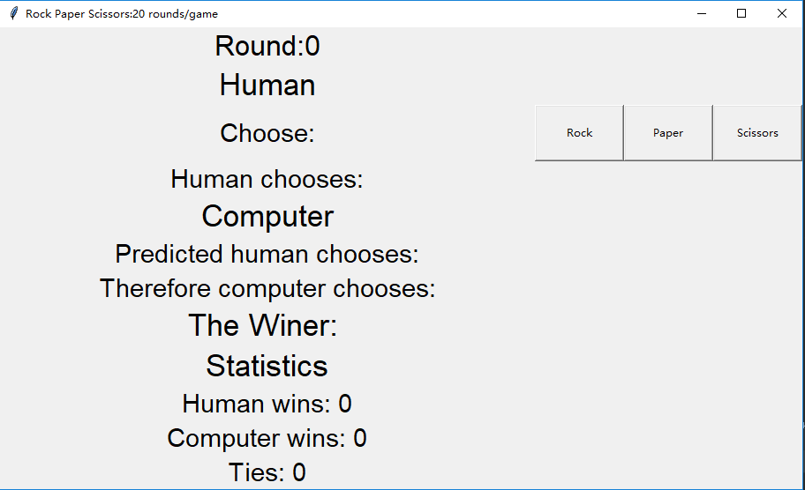

3.Output（Then you can continue to click those Button again）

